**Conditional operator**

Conditional Operator (? :) is the only **ternary** operator in JavaScript, it also called “**question mark**” operator. It accepts 3 operands.

**Note:** Conditional operator is kind of short hand notation for if else statement in JavaScript.

**Syntax:** **let** **variable** = **(condition) ?** **operand2 :** **operand3**;

**Where:**

* operand1: should be a condition
* operand2: executed value if the condition is **true**.
* operand3: executed value if the condition is **false**.

**Example:**

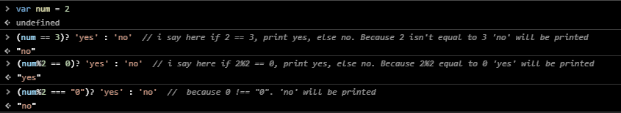

**Note:** you can omit the parentheses around the condition as **?** Operator has a low precedence so it will execute after all exacting operators. But it’s better two writes () two make the code more readability.

**Example:**

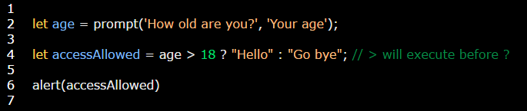

**Note:** you can use multiple question mark operators.

**Example:** it just like saying if…else conditions. Where if is **(condition)?** While else is operand after**:**

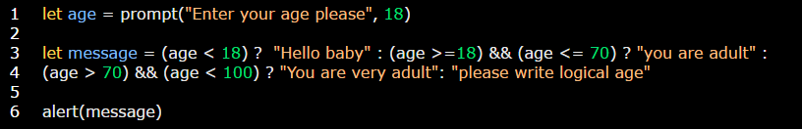

**Note:** you can use functions as an operands in question mark operator.

**Example:**

